••••••••••••••••••• **Module (Bootstrap Basic & Advanced) – 6** •••••••••••••••••••••

**1• What are the advantages of Bootstrap?**

ANS.

Bootstrap offers many advantages for web designers and developers, such as saving time and effort by providing ready-made components and styles that can be customized and combined. It also ensures consistency and compatibility, as it follows a standard design and coding convention, and uses a mobile-first approach.

•••••••••••••••••••••••••••••••••••••••••••••••••••••••••••••••

**2• What is a Bootstrap Container, and how does it work?**

ANS.

In Bootstrap, container is used to set the content's margins dealing with the responsive behaviors of your layout. It contains the row elements and the row elements are the container of columns (known as grid system). The container class is used to create boxed content.

1.Fixed Width:

A Bootstrap container has a fixed maximum width. This width varies based on the screen size or viewport. By default, Bootstrap containers have different maximum widths for different screen sizes:

Extra Small (xs): <576px

Small (sm): ≥576px

Medium (md): ≥768px

Large (lg): ≥992px

Extra Large (xl): ≥1200px

2.Centered Content:

3.Responsive Design

4.Padding and Margins

•••••••••••••••••••••••••••••••••••••••••••••••••••••••••••••••

**3• What are the default Bootstrap text settings?**

ANS.

Bootstrap 4 Default Settings

Bootstrap 4 uses a default font-size of 16px, and its line-height is 1.5. The default font-family is "Helvetica Neue", Helvetica, Arial, sans-serif. In addition, all <p> elements have margin-top: 0 and margin-bottom: 1rem (16px by default).

•••••••••••••••••••••••••••••••••••••••••••••••••••••••••••••••

**4• What do you know about the Bootstrap Grid System?**

ANS.

Bootstrap's grid system uses a series of containers, rows, and columns to layout and align content. It's built with flexbox and is fully responsive. Below is an example and an in-depth look at how the grid comes together. New to or unfamiliar with flexbox?

--> Bootstrap's grid system allows up to 12 columns across the page.

If you do not want to use all 12 column individually, you can group the columns together to create wider columns:

[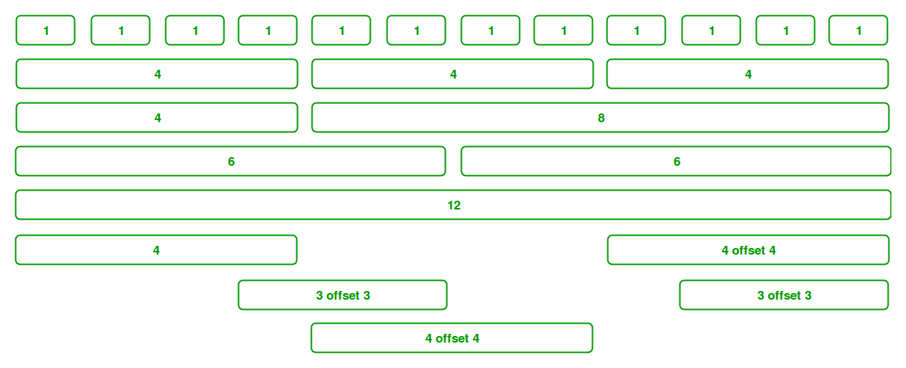](https://media.geeksforgeeks.org/wp-content/uploads/Bootstrap-part-2.png)

--> Grid Classes: The Bootstrap grid system has four classes that can be combined to make

more flexible layouts:

xs (<576px): For Portrait Mobile Phones.

sm (>=576px): For Landscapes phones

md (>=768px): For Tablets/Phablets

lg (>=992px): For Small-sized Desktops/Laptops

xl (>=1200px): For Larger-sized Desktops/Laptops

•••••••••••••••••••••••••••••••••••••••••••••••••••••••••••••••

**5• What is the difference between Bootstrap 4 and Bootstrap 5**

ANS.

Difference between Bootstrap 4 and Bootstrap 5

| **BASIS OF** | **BOOTSTRAP 4** | **BOOTSTRAP 5** |
| --- | --- | --- |
| **Grid System** | It has 5 tier (xs, sm, md, lg, xl). | It has 6 tier (xs, sm, md, lg, xl, xxl). |
| **Color** | It has limited colors. | Extra colors added with the looks, A card improved color palette. there are various shades available to choose. |
| **Jquery** | It has jquery and all related plugins. | Jquery is removed and switched to vanilla JS with some working plugins |
| **Internet Explorer** | Bootstrap 4 supports both IE 10 and 11. | Bootstrap 5 doesn’t support IE 10 and 11. |
| **Form elements** | Radio buttons, checkboxes have different look in different OS and browsers. The form uses whatever default browsers provide. | The look of form elements will not change, on different OS or browser. The forms can be customized and form controls can be added, they would not depend on browser. |
| **Utilities API** | We cannot modify utilities in bootstrap 4 | Bootstrap 5 gave freedom to modify and also create our own utility |
| **Gutter** | We use .glutter with fontsize in px | We use .g* with fontsize in rem |
| **Vertical Classes** | Columns can be positioned relative | Columns cannot be positioned relative |
| **Bootstrap Icons** | Bootstrap 4 doesn’t have its own SVG icons, we have to use font-awesome for icons. | Bootstrap 5 have its own SVG icons |
| **Jumbotron** | It supports. | It doesn’t support jumbotron. |
| **Card deck** | The card deck is used to create a set of cards with equal width and height. | Card deck class in removed in bootstrap |
| **Navbar** | We have inline-block property and we will get white dropdown as default for dropdown-menu-dark class. | Inline-block property is removed and we will get black dropdown as default for dropdown-menu-dark class. |
| **Static Site Generator** | Bootstrap 4 uses Jekyll software. | Bootstrap 5 uses Hugo software as it is fast static site generator. |
| **RTL Support** | It does not enable RTL(Right to Left) switching. | It enables RTL(Right to Left) switching. |
| **Offcanvas Component** | It does not support Offcanvas Component. | It supports Offcanvas Component(that is it is available now). |

•••••••••••••••••••••••••••••••••••••••••••••••••••••••••••••••

6• What is a Button Group, and what is the class for a basic Button Group?

ANS.

“Button Groups” in Bootstrap is a class of name “btn-group” which is used to create a series of buttons in groups (without spaces) vertically or horizontally.

Syntax: This is the basic syntax of the button group class where each button has its own class of “btn”.

Buttons have a default border-radius on the first and last buttons of the group.

•••••••••••••••••••••••••••••••••••••••••••••••••••••••••••••••

**7• How can you use Bootstrap to make thumbnails?**

Ans.

Creating a thumbnail

Step 1: The first step is to include the Bootstrap and jQuery CDN into the head tag before having CSS's stylesheets. Step 2: We need to create a div tag in our HTML body. We will create three div sections for each image in this div tag.

Step by step guide for the implementation:

Step 1: Include Bootstrap and jQuery CDN into the <head> tag before all other stylesheets to load our CSS.

Step 2: Add <div> tag in the HTML body with class row. In that <div> create four div sections to create four images.

Step 3: Add “col-sm-6” and “col-md-3” to four div sections which creates webpage responsive.

Step 4: Add <a> tag with class value thumbnail to define the link of the image in the next line.

Adding captions and buttons to the thumbnails :

Step 1: We created div with class value as thumbnail and inserted image, after that add div with class .caption to define the description of the images <p>.

Step 2: Create buttons using <a> tag with class . btn .btn-success.

•••••••••••••••••••••••••••••••••••••••••••••••••••••••••••••••

**8• In Bootstrap 4, what is flexbox?**

Ans.

Flexbox. The biggest difference between Bootstrap 3 and Bootstrap 4 is that Bootstrap 4 now uses flexbox, instead of floats, to handle the layout. The Flexible Box Layout Module, makes it easier to design flexible responsive layout structure without using float or positioning.

•••••••••••••••••••••••••••••••••••••••••••••••••••••••••••••••

**9• How can one create an alert in Bootstrap?**

Ans.

Here's how:

1. Be sure you've loaded the alert plugin, or the compiled Bootstrap JavaScript.

2. If you're building our JavaScript from source, it requires util.js . ...

3. Add a dismiss button and the .alert-dismissible class, which adds extra padding to the right of the alert and positions the .close button.

•••••••••••••••••••••••••••••••••••••••••••••••••••••••••••••••

**10• What is a bootstrap card and how would you create one?**

Ans.

In its simplest form, a Bootstrap card is a . card class with the . card-body class nested inside. This creates a card with a rounded border inside which you can place text, images, links, and other Bootstrap elements.